

East West University

Differential Equations and Special Functions (MAT102)
Home-Assignment: MATLAB Assignment

Submitted by –
Rifa Azad
ID# 2022-1-60-265
Section: 1

Submitted to –
Dr. Anindita Paul
Professor
Department of Mathematical and Physical Sciences

Date of Submission: September 04, 2022

Problem 1
Solve the differential equation using MATLAB. Then show how the result will change when the initial–values are changed.
Consider first y(0) = 0, y′(0) = -5 and then y(0) = -1, y′(0) = 1.
Then plot the solutions by considering 25 ≤ x ≤ 30 in the same figure to observe the difference.

Problem 2
Solve the initial-value problem using MATLAB, where y(0) = −1, y′(0) = 0, y′′(0) = 2, y′′′(0) = −1.
Then plot the solution for −5 ≤ x ≤ 5.

Solution of Problem 1

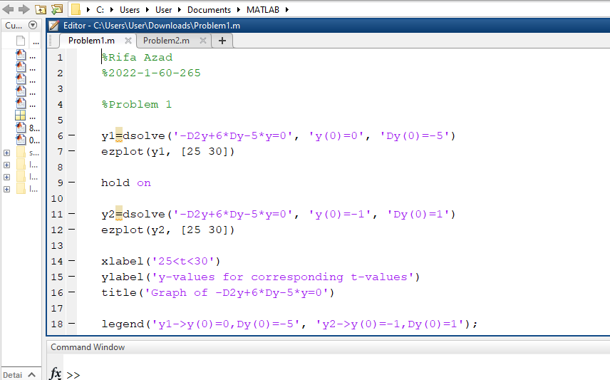

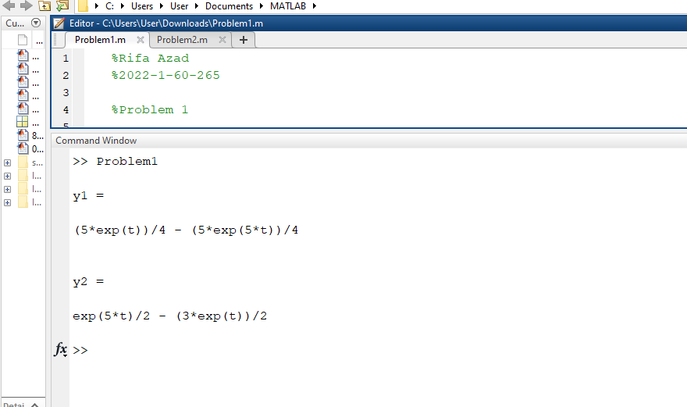

Solution of Problem 2

